Insert the following 3 new rows into the student table:

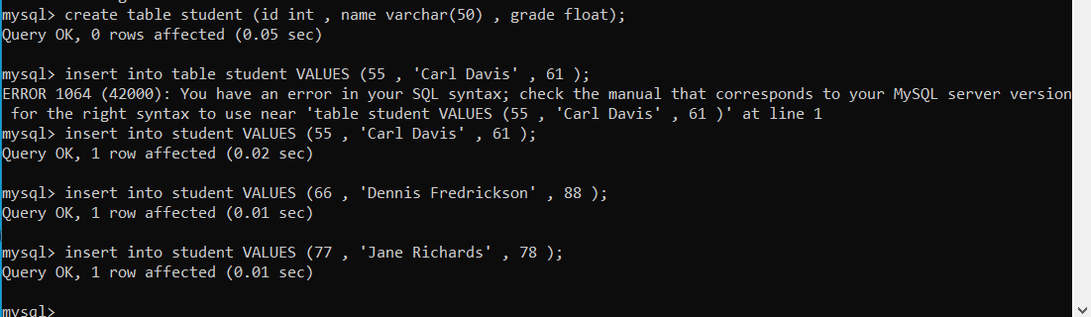

* Select all records with a grade between 60 and 80

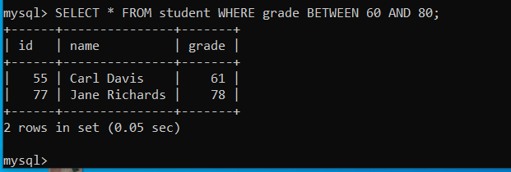

* Change Carl Davis’s grade to 65

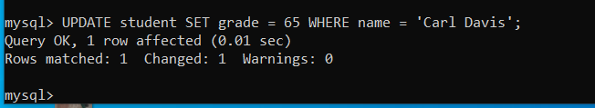

* Delete Dennis Fredrickson’s row

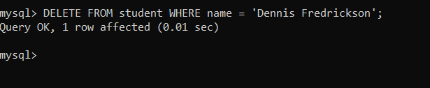

* 6. Change the grade of all people with an id greater than 55 to 80.

